**Duty ID Generator**

***Work-flow to Use Duty ID Generator***

The Duty ID Generator preference is accessed through **Load Template** and only one instance of it is permitted.

***Preference Overview***

If this preference is left unchecked, duties (Driver blocks) in the Driver Gantt will be numbered sequentially from 1.

If the preference template is used, the optimizer will try to number the driver duties so that successive duties using the same vehicle appear consecutively.Here is an example:

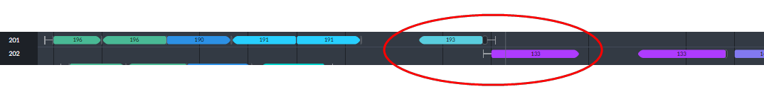

The circled service trips use the same vehicle as shown in their information boxes below:

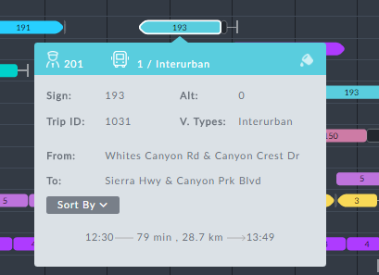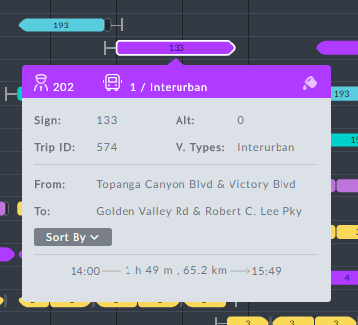

***Templates Available from Optibus***

***Simple duty id generator***

**Purpose:**

As stated in the Overview **Prerequisites:** None. **Opening Dialog:**

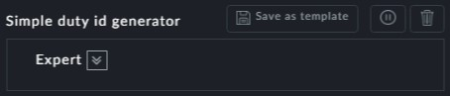

**Point to note:**

There is nothing further to do here - just click **Save** and continue



This preference functions as a toggle. To untoggle it, you must re-enter the pref-



erence and use the button



The Duty ID Generator can be tailored to customer requirements. For

example, an opreator might require 1-200 to be duties that share a vehicle,

400-500 to be duties that do not share a vehicle, 600-700 to be split duties and so on…